https://www.geeksforgeeks.org/decision-tree-introduction-example/
2. Gini Index
- Gini Index is a metric to measure how often a randomly chosen element would be incorrectly identified.
- It means an attribute with lower Gini index should be preferred.
- Sklearn supports “Gini” criteria for Gini Index and by default, it takes “gini” value.
- The Formula for the calculation of the of the Gini Index is given below.

Example:
Lets consider the dataset in the image below and draw a decision tree using gini index.

Index | A | B | C | D | E
1 | 4.8 | 3.4 | 1.9 | 0.2 | positive
2 | 5 | 3 | 1.6 | 1.2 | positive
3 | 5 | 3.4 | 1.6 | 0.2 | positive
4 | 5.2 | 3.5 | 1.5 | 0.2 | positive
5 | 5.2 | 3.4 | 1.4 | 0.2 | positive
6 | 4.7 | 3.2 | 1.6 | 0.2 | positive
7 | 4.8 | 3.1 | 1.6 | 0.2 | positive
8 | 5.4 | 3.4 | 1.5 | 0.4 | positive
9 | 7 | 3.2 | 4.7 | 1.4 | negative
10 | 6.4 | 3.2 | 4.7 | 1.5 | negative
11 | 6.9 | 3.1 | 4.9 | 1.5 | negative
12 | 5.5 | 2.3 | 4 | 1.3 | negative
13 | 6.5 | 2.8 | 4.6 | 1.5 | negative
14 | 5.7 | 2.8 | 4.5 | 1.3 | negative
15 | 6.3 | 3.3 | 4.7 | 1.6 | negative
16 | 4.9 | 2.4 | 3.3 | 1 | negative
In the dataset above there are 5 attributes from which attribute E is the predicting feature which contains 2(Positive & Negative) classes. We have an equal proportion for both the classes.
In Gini Index, we have to choose some random values to categorize each attribute. These values for this dataset are:
A B C D
>= 5 >= 3.0 >= 4.2 >= 1.4
< 5 < 3.0 < 4.2 < 1.4
Calculating Gini Index for Var A:
Value >= 5: 12
Attribute A >= 5 & class = positive: 5/12
Attribute A >= 5 & class = negative: 7/12
Gini(5, 7) = 1 –
Value < 5: 4
Attribute A < 5 & class = positive:
Attribute A < 5 & class = negative:
Gini(3, 1) = 1 –
By adding weight and sum each of the gini indices:
Calculating Gini Index for Var B:
Value >= 3: 12
Attribute B >= 3 & class = positive:
Attribute B >= 5 & class = negative:
Gini(5, 7) = 1 –
Value < 3: 4
Attribute A < 3 & class = positive:
Attribute A < 3 & class = negative:
Gini(3, 1) = 1 –
By adding weight and sum each of the gini indices:
Using the same approach we can calculate the Gini index for C and D attributes.
Positive Negative
For A|>= 5.0 5 7
|<5 3 1
Ginin Index of A = 0.45825
Positive Negative
For B|>= 3.0 8 4
|< 3.0 0 4
Gini Index of B= 0.3345
Positive Negative
For C|>= 4.2 0 6
|< 4.2 8 2
Gini Index of C= 0.2
Positive Negative
For D|>= 1.4 0 5
|< 1.4 8 3
Gini Index of D= 0.273

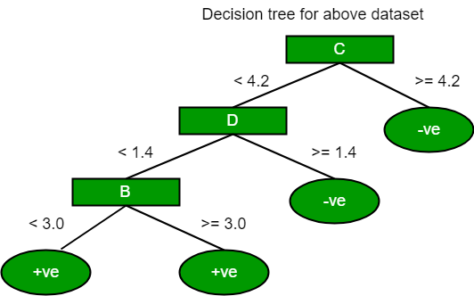
The most notable types of decision tree algorithms are:-
1. Iterative Dichotomiser 3 (ID3): This algorithm uses Information Gain to decide which attribute is to be used classify the current subset of the data. For each level of the tree, information gain is calculated for the remaining data recursively.
2. C4.5: This algorithm is the successor of the ID3 algorithm. This algorithm uses either Information gain or Gain ratio to decide upon the classifying attribute. It is a direct improvement from the ID3 algorithm as it can handle both continuous and missing attribute values.
3. Classification and Regression Tree(CART): It is a dynamic learning algorithm which can produce a regression tree as well as a classification tree depending upon the dependent variable.
V
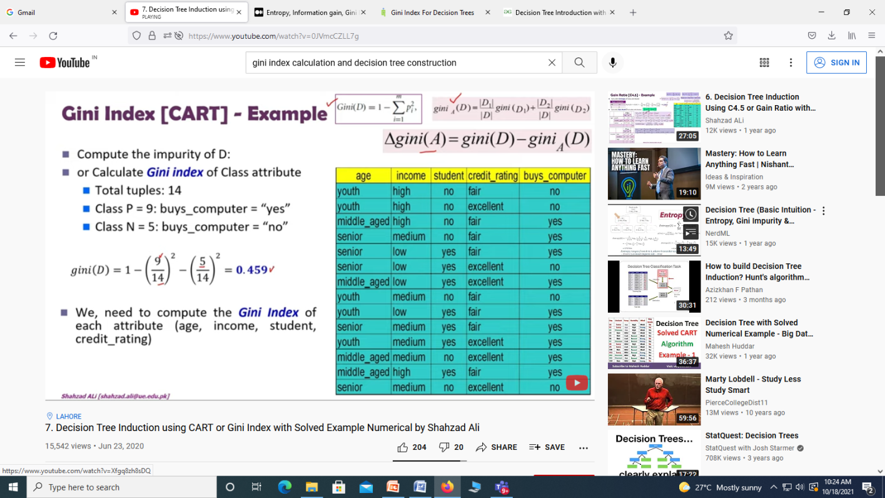

Example:
Lets consider the dataset in the image below and draw a decision tree using gini index.
Index | A | B | C | D | E
1 | 4.8 | 3.4 | 1.9 | 0.2 | positive
2 | 5 | 3 | 1.6 | 1.2 | positive
3 | 5 | 3.4 | 1.6 | 0.2 | positive
4 | 5.2 | 3.5 | 1.5 | 0.2 | positive
5 | 5.2 | 3.4 | 1.4 | 0.2 | positive
6 | 4.7 | 3.2 | 1.6 | 0.2 | positive
7 | 4.8 | 3.1 | 1.6 | 0.2 | positive
8 | 5.4 | 3.4 | 1.5 | 0.4 | positive
9 | 7 | 3.2 | 4.7 | 1.4 | negative
10 | 6.4 | 3.2 | 4.7 | 1.5 | negative
11 | 6.9 | 3.1 | 4.9 | 1.5 | negative
12 | 5.5 | 2.3 | 4 | 1.3 | negative
13 | 6.5 | 2.8 | 4.6 | 1.5 | negative
14 | 5.7 | 2.8 | 4.5 | 1.3 | negative
15 | 6.3 | 3.3 | 4.7 | 1.6 | negative
16 | 4.9 | 2.4 | 3.3 | 1 | negative
In the dataset above there are 5 attributes from which attribute E is the predicting feature which contains 2(Positive & Negative) classes. We have an equal proportion for both the classes.
In Gini Index, we have to choose some random values to categorize each attribute. These values for this dataset are:
A B C D
>= 5 >= 3.0 >= 4.2 >= 1.4
< 5 < 3.0 < 4.2 < 1.4
Calculating Gini Index for Var A:
Value >= 5: 12
Attribute A >= 5 & class = positive:
Attribute A >= 5 & class = negative:
Gini(5, 7) = 1 –
Value < 5: 4
Attribute A < 5 & class = positive:
Attribute A < 5 & class = negative:
Gini(3, 1) = 1 –
By adding weight and sum each of the gini indices:
Calculating Gini Index for Var B:
Value >= 3: 12
Attribute B >= 3 & class = positive:
Attribute B >= 5 & class = negative:
Gini(5, 7) = 1 –
Value < 3: 4
Attribute A < 3 & class = positive:
Attribute A < 3 & class = negative:
Gini(3, 1) = 1 –
By adding weight and sum each of the gini indices:
Using the same approach we can calculate the Gini index for C and D attributes.
Positive Negative
For A|>= 5.0 5 7
|<5 3 1
Ginin Index of A = 0.45825
Positive Negative
For B|>= 3.0 8 4
|< 3.0 0 4
Gini Index of B= 0.3345
Positive Negative
For C|>= 4.2 0 6
|< 4.2 8 2
Gini Index of C= 0.2
Positive Negative
For D|>= 1.4 0 5
|< 1.4 8 3
Gini Index of D= 0.273

The most notable types of decision tree algorithms are:-
1. Iterative Dichotomiser 3 (ID3): This algorithm uses Information Gain to decide which attribute is to be used classify the current subset of the data. For each level of the tree, information gain is calculated for the remaining data recursively.
2. C4.5: This algorithm is the successor of the ID3 algorithm. This algorithm uses either Information gain or Gain ratio to decide upon the classifying attribute. It is a direct improvement from the ID3 algorithm as it can handle both continuous and missing attribute values.
3. Classification and Regression Tree(CART): It is a dynamic learning algorithm which can produce a regression tree as well as a classification tree depending upon the dependent variable.

